# ML Coursework Tutorial 10

Jqk17

1. Decision function for dataset 1

Using Support Vector Machines

1. Decision process
   1. Neural Network takes far longer than the Support Vector Machine for similar output
   2. Machine learning algorithm does the “hard work” so you do not have to analytically derive the equation, and also does not require the friction coefficient
   3. You don’t need to use a ML algorithm to draw the boundary, you can draw one by hand if you print a scatter plot of f2 against f2ang:

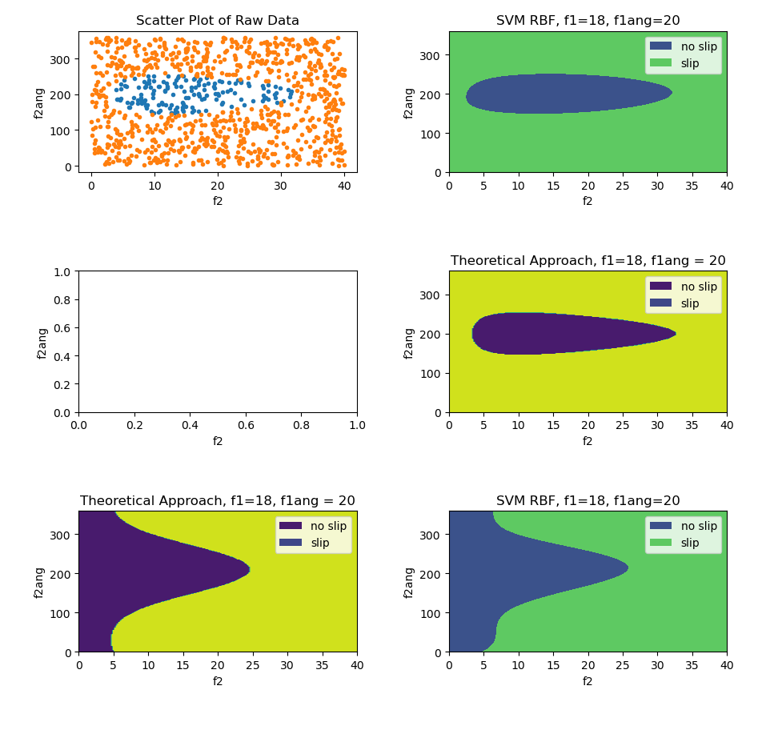

1. Theoretical friction approach:
   1. Left hand side boundary is sharper, and the boundary is symmetrical about 200N which is expected

1. Varying force 1

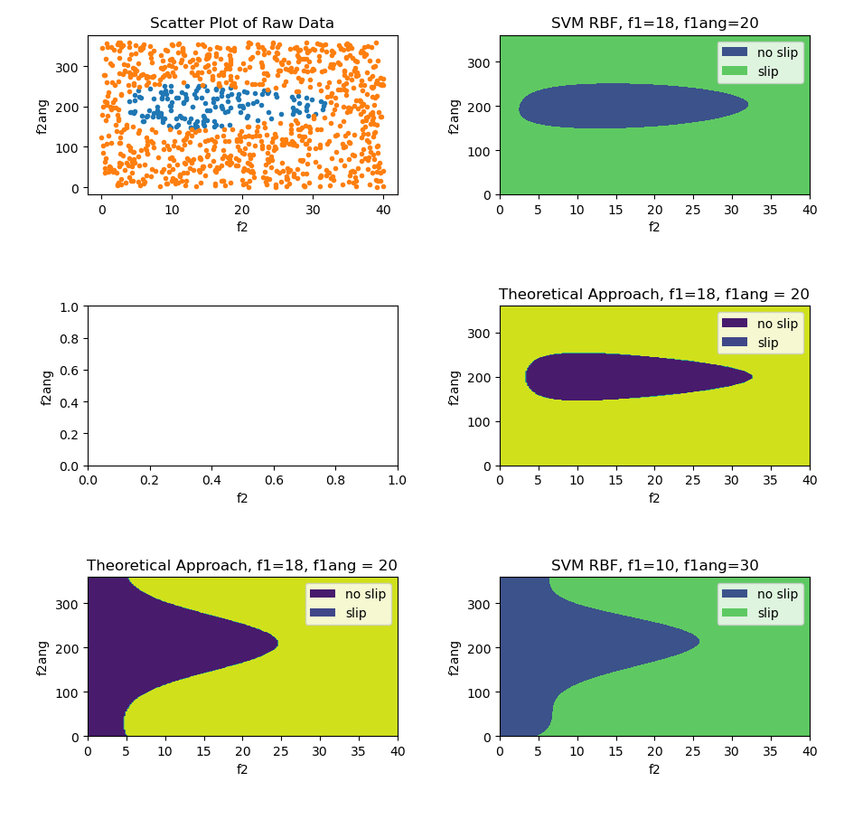

1. Change in dataset points

Necessary because of added dimension, at each f1 and f1ang, a whole set of f2 and f2ang is needed